2017 YAMAHA NZ Jet Sport Nationals

31st March – 2nd April,
Onepoto Road, Titahi Bay, Porirua

Hi All,

The 2017 Nationals will be held on Porirua Harbour at Onepoto Clubrooms. They will be run over 3 days from March 31st to April 2nd and will be hosted by the Wellington Jet Sport Club. We will be running five rounds on Friday, four rounds on Saturday and three rounds on Sunday. We will be running Watercross just prior to lunch Saturday and Sunday. Please note we will not have any tents or onsite security so you will need to transport your skis to and from the race venue for all race days. There will be parking available at the venue but you need to have your own trolley, you will not be able to launch your ski’s directly from your trailers.

Schedule
Registration & Scrutineering:
Thursday 5:00pm – 8:00pm
Friday 5:00pm – 8:00pm

Riders Brief: Friday 8:00 am, Saturday 8:00am
Look Laps (E/E): Friday 8:30am, Saturday 8:30am
Look Laps (Novice): Friday 9:00am
Racing Starts: Friday 9:30am
Saturday 9:30am
Sunday 10:00am

Entries
Entry Forms and payment must be received prior to March 17th. There will be a $100.00 late fee for any entries or payment received after this. Entry Forms can either be completed online and emailed to maggie@wjsc.co.nz or be sent via post to:

Wellington Jet Sports Club
C/O: 12 Chanel Grove
Waterloo
Lower Hutt 5011

Payment can either be sent to the address above or paid online to
WJSC, BNZ Porirua 02-0576-0177669-00
Please use your full name as a reference.

AGM
This will be held at the Wellington Power Boat Clubrooms in Onepoto Road. This will be held Friday 31st March 7:30pm at this stage.

Food at Venue
There will be food and refreshments available for purchase on all days of racing.

Accommodation
Here are a few options of accommodation; all within 10 minutes drive to the race venue and also close to The Supply Room where prize giving will be held.

Aotea Lodge http://www.aotealodge.co.nz/

Belmont Lodge – caters to families and groups http://www.belmontmotorlodge.co.nz/

Mana Motel http://www.manamotel.co.nz/

Amethyst Court http://www.amethystcourt.co.nz/

Spinnaker Motel http://www.spinnakermotel.co.nz/

Location
Onepoto Clubrooms are located about 5 minutes drive from central Porirua. Below is a map from Google Maps to help you find it.
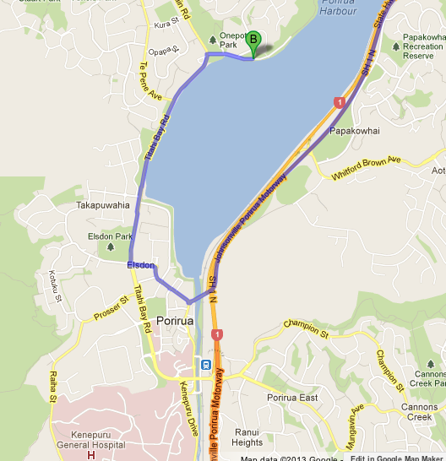

Prize Giving
The prize giving will be held on Sunday 2nd April at The Supply Room in Paremata. This is located at 105 Mana Esplanade, Paremata. Prize giving will start at 7:00pm.
http://www.supplyroom.co.nz/
Tickets for prize giving are $25 which will include dinner of your choice from a set menu.

For any queries or additional information please free feel to contact either Craig Boyd on 021 766 264 Maggie Lampe on 022 465 2673 or email maggie@wjsc.co.nz

