NORTH ISLAND SUMMER TOUR, 2016/2017
FIVE MILE BAY, TAUPO ROUNDS
11th & 12th FEBRUARY, 2017
The Auckland Jet Ski Riders Association is proud to host the next two rounds of the North Island Summer Tour to be held at the Tawhaa Street Reserve, Five Mile Bay, Lake Taupo on Saturday and Sunday, 11th and 12th of February.
Five Mile Bay is a great new venue with heaps of parking right alongside the lake. It’s perfect for the use of beach trolleys however if you don’t have one you can always launch at Two Mile Bay, or Three Mile Bay just up the road. Ramp passes cost $5.00 per day. If you need a ramp pass you can apply online here.
You’ll need to bring your own food and drink as there are no vendors on site. There are however cafés galore in Taupo.
DIRECTIONS TO THE VENUE
Access to the venue is really easy. Tawhaa Street is two roads South of the Taupo Airport roundabout and the reserve is at the end of the street.
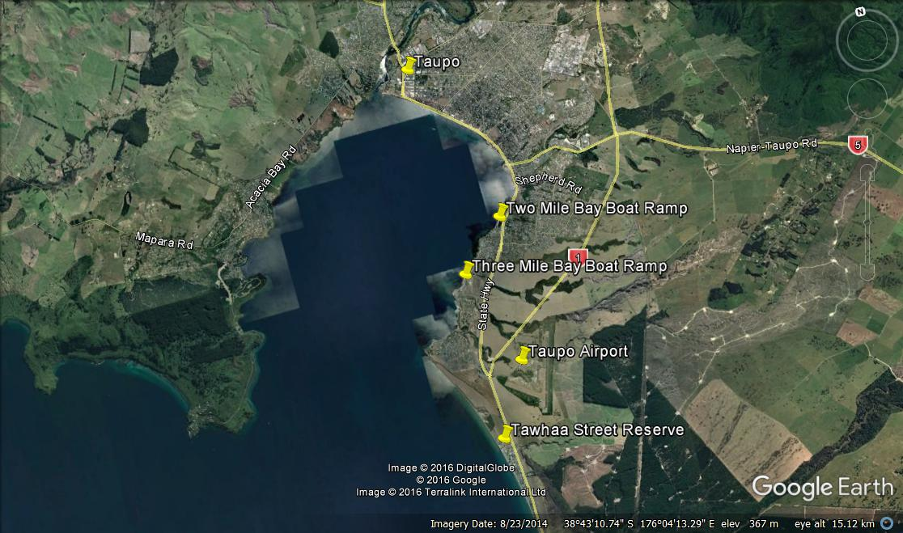

The pre-race schedule for the day is as follows:
8:30am – 9.45am | Registration and Scrutineering/ Safety Checks
10.00am | Riders Briefing
10.15am | Look Laps
10.30am -11.00 | Racing Starts
SCRUTINEERING
Your vessel and race gear will be scrutineered to ensure they comply with the NZJSBA safety criteria. You will personally need to wear a compliant helmet and life vest (PDF 3 or 5) and have a tow loop attached to your ski. Pole Ski riders must have a compliant back brace. It is also recommended that riders wear footwear, wetsuit, goggles and gloves, and have with them, a fire extinguisher. All skis will also be scrutineered prior to racing.
REGISTRATION
Please send your fully-completed entry form to Aucklandjetski@gmail.com as soon as possible. Payment on the day will be accepted and Eftpos is available on site.
If you have any questions or queries about the event don’t hesitate to contact Club President John Wright on 027 444 8 222.
RACE LICENSE
All competitors must hold a current NZJSBA Race License. A Full season NZJSBA Race License costs $140.00. Riders may also compete on a Day Licence (cost $30.00) to a maximum of 2 Day Licences in a year. Points earned on a Day Licence, however, do not count towards season points. First Time competitors receive one complimentary Day License.
If you are applying for a license for the first time please bring along photo ID for officials to view.
If you are under 18yrs, your license must be signed by a parent or guardian.
DOC REQUIREMENTS

A new and invasive water weed was found on a jet ski trailer launching into a North Island lake last year and as a result DOC have notified us that they will be closely monitoring the launching of ALL Skis etc.
It is essential that ALL trailers skis and gear, especially those from the South Island (where Didimo is established) or used in Fresh Water are completely cleaned and dried before leaving home and at least 3 days prior to launching anywhere on Lake Taupo.
We look forward to seeing you at the event. Tell your friends and help us by advertising it on your Facebook page.
Regards,
Auckland Jet Ski Riders Association
Aucklandjetski@gmail.com

