Farnley’s Jet Skis Kawasaki
Hatfield’s Beach Sprint Challenge
Winter Endurance Races

~Official Entry Form~
Hosted by the Auckland Jet Ski Riders Assn. Sanctioned by NZJSBA
Date: Saturday October 29th 2016
Venue: Hatfields Beach. Hibiscus Coast. Auckland
Race Start 11.00am

Riders Details
Name: ………………………………………..…………………....NZJSBA Licence #.................
Name: …………………………………………..………...............NZJSBA Licence #.................

Team Name:…………………………………………..…………
Race Number:……………………..
Phone Number:…………………………………………………
Email Address:………………………………………………….
PWC Make/Model:…………………………………………….
Classes. All subject to numbers.
- Runabout Open………………… …………………………….$80.00
- Runabout Stock ……………………………………………....$80.00
- Naturally Aspirated ………………………………..……….$80.00
- Runabout Teams …………………….…………………….$100.00
Team entry includes 2 riders. Extra riders $20each

Total Due:$..................
DC payment: AJSRA 02-0214-0147120-000. Name reference please

Vests must be minimum PFD STD 3. Wet suit inc Long johns, Suitable footwear, Regulation Helmet, Skis safety checked. Some WARM Clothing.

All Riders MUST sign an NZJSBA Indemnity Form
A parent or guardian MUST sign if the competitor is under 18 years of age.

Prize Giving: Orewa Surf Club. Main Road Orewa
Hot showers, Hot Food, Cool Drinks
Plenty of Excellent; Food, Liquid Refreshment and Hospitality.

Info Contact: John Wright 027 444 8 222 or jetski@acmeelectric.co.nz
Mark Roscoe 021 870 742 or mark.roscoe@hotmail.co.nz

Race Program Hatfield’s Beach Sprint Challenge October 29th
Scrutineering and Registration From 9.00am
Riders Briefing and Course Familiarisation 10.30am

Race Start 1st of 3 races 11.30pm
Racing Finish Approx. 2.30pm
Prize Giving From 5.00pm

Jet skis will race 3 races of approx. 25 minutes each, these will total to a final placing.
The plan is to achieve 100 miles total race distance, weather dependent.
Riders may choose to ride 1, 2 or 3 of the races, depending on fitness and conditions.
It is configured to be Fun as well as Competitive.

Prize giving will be held at the Orewa Surf Club, Bar and Bistro. Main Road Orewa

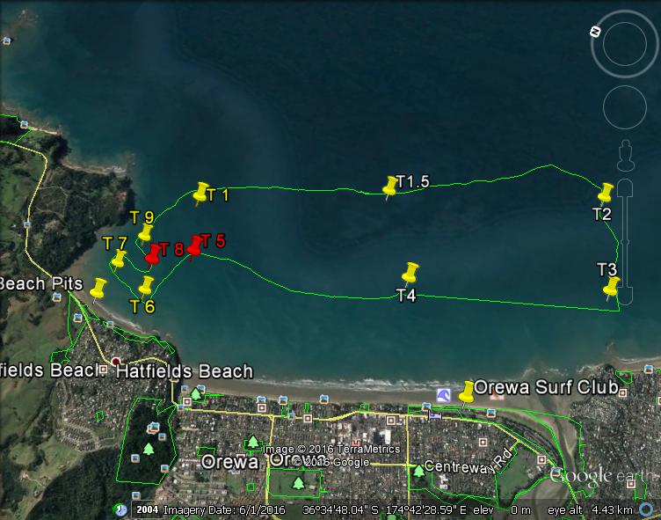

Hatfield’s Beach is located 2 minutes over the hill from Orewa Beach on the Hibiscus Coast Highway. Take the Orewa off ramp from the Northern Motorway to Grand Drive and follow it down to Hibiscus Coast Highway and turn left and head over the hill. Hatfield’s has easy beach access with plenty of parking. Boat trailers may be left on the beach, but at this stage not cars.

