Herb Morgan Tyres and Wheels Onehunga Sprints Challenge
Winter Endurance Challenge

~Official Entry Form~
Hosted by the Auckland Jet Ski Riders Assn. Sanctioned by NZJSBA
Date: Saturday July 23rd 2016
Venue: Taumanu Reserve Onehunga Bay. Auckland
Racing Starts 11.00 am

Riders Details
Name: ………………………… NZJSBA Licence #.................
Name: …………………………………………..………...............NZJSBA Licence #.................

Team Name:…………………………………………..…………
Race Number:………………………
Phone Number:……………………………
Email Address:………………………………………….
PWC Make/Model:………………………………………………
Classes. All subject to numbers.
- Runabout Open………………………………………..…………….$80.00
- Runabout Stock ………………………………………….……….....$80.00
- Naturally Aspirated …………………………….………...……….$80.00
- Runabout Teams ………2 Riders….…………..………..…….$100.00
- First Time Rider………………Information only
- First Day License for Riders is Free. Class fee applies….$ N/c
- Day License if required……………………….…………………..…$30.00

Total………………

DC payment: AJSRA 02-0214-0147120-001. Name reference please

Vests must be minimum PFD STD 3. Wet suit Inc. Long Johns, Suitable footwear, Regulation Helmet, Skis safety checked. Some WARM Clothing.

All Riders MUST sign an NZJSBA Indemnity Form
A parent or guardian MUST sign if the competitor is under 18 years of age.

Prizemoney for all Classes: “Cash”

Prize Giving Venue “The Landing Restaurant and Bar”
2 Onehunga Harbour Road, Opposite the Onehunga Wharf

Info Contact: John Wright 027 444 8 222 or jetski@acmeelectric.co.nz
Club Email; Aucklandjetski@gmail.com

We are doing it again!!!

Come Ride With Us

Race Program
Scrutineering and Registration From 9.00am
Riders Briefing and Course Familiarisation 10.00am
Race Start 1st of 3 Races 11.00am
Thunder Cats 1st of 3 Races 11.30am
Racing Finish Approx. 2.30pm
Prize Giving The Landing Restaurant and Bar From 4.00pm

Jet Skis will race 3 races of approx. 25 minutes each, these will total to a final placing,
The plan is to achieve 100 miles total race distance, weather dependent
Riders may choose to ride 1, 2 or 3 of the races, depending on fitness and conditions

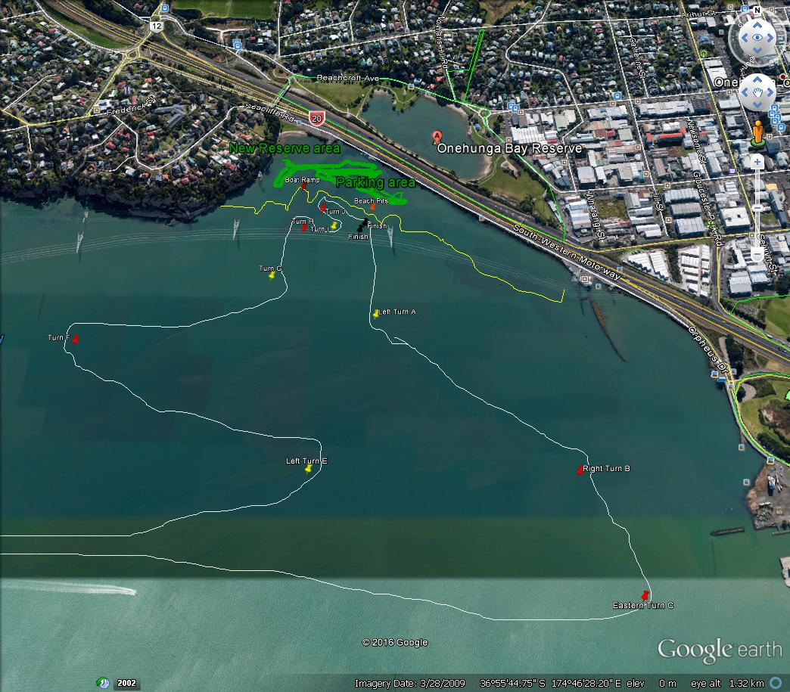

The Herb Morgan Onehunga Sprint Challenge.
Will be a total of 3 races. All races will start together and shall be timed (approx. 25minutes) + 1 lap . Fuel may be necessary to cover race distances so competitors need to plan on having enough fuel for their particular crafts fuel consumption. And the ability to remove skis above high water mark for refuelling.

The 7km course will take riders close to the New beach area and out into the harbour area while the total distance has not changed the shortened laps should keep the field together longer a provide plenty of close racing and excitement for the spectators.

The Venue
Taumanu Reserve, Onehunga Bay Onehunga Auckland City.
Access is via Orpheus Drive, from either the east or west, as it is Parallel to the motorway, the Onehunga exit from the Southwestern motorway heading North, Take the exit and turn Right at the end then proceed onto Orpheus Drive follow it along to the venue.
From the Motorway heading South, Take the exit to Onehunga( Neilson Street) proceed to the third set of traffic lights turn Right and go past Herb Morgan Tyres, proceed along and under the motorway around past the Wharf and you will get to Orpheus drive on the left.
From Queenstown Road, at the Southern end turn Left onto Fredrick Street and then Right onto Seacliffe Road, continue all the way down to the venue at the bottom of the hill.
Large concrete boat ramp and ample parking.
Parking will be available on grass reserve above the sandy beach venue.

Riding Attire
Riders will be required to wear an approved helmet, vest, wetsuit and footwear A full length wetsuit, boots or shoes, gloves and goggles are highly recommended.
Depending on weather conditions, a tour coat or windproof jacket may also be a good idea.

Prizegiving Venue.
“The Landing Restaurant and Bar” 2 Onehunga Harbour Road,
Built in 1865, The Landing offers relaxed, affordable a la carte dining.
Nowhere else in Auckland will you find the unique combination of a restaurant and bar offering the freshest New Zealand fish, seafood and NZ European dining.
Built in 1865, The Landing offers relaxed, affordable a la carte dining.

Spectators
It is recommended that family and crew should bring their own food and drinks. At this stage there is no onsite catering.
Onehunga is only 5 minutes away and has numerous bakeries and cafe’s.

This is an exciting piece of water that is perfectly suited to endurance style racing. The planned course is a very simple big rectangle with a few turns that takes riders across the front this now popular beach and should provide spectacular viewing for locals who would have not ever seen PWC racing in these waters.

We look forward to seeing as many of you out there as possible!

Added Spectator Activity
The Thunder Cat Racers, Our Friends in On Water Action and Excitement.
Will be in attendance and providing their own type of Endurance Racing between the jet ski races, these will provide some real action with beach starts, enforced beach landings, tagging and returning to the circuit to complete their 3 races, Thrills and spills in these fun, fast little boats.
Remember “Rubbing is Racing”

